Lab Manual

Data Communication Networks

BCA324

III

NAME = SUJAL KHUNT

ENROLL= 24FOTCA13902

TUTORIAL 7

Q-1 )Explore the route for reaching following website. [http://www.rku.ac.in](http://www.rku.ac.in/)

ANs-tracert [www.rku.ac.in](http://www.rku.ac.in/)

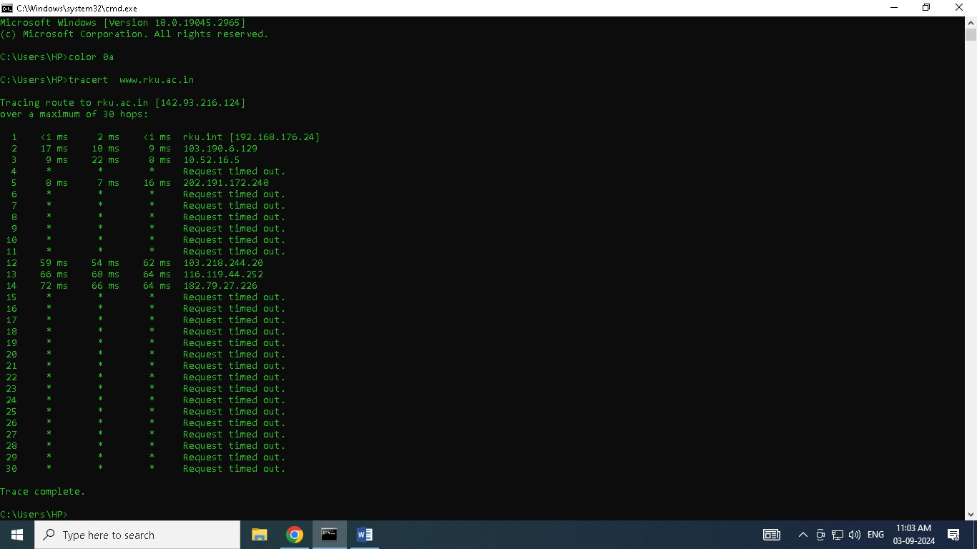

Q-2) [http://www.gmail.com](http://www.gmail.com/)

ANS- tracert [www.gmail.com](http://www.gmail.com/)

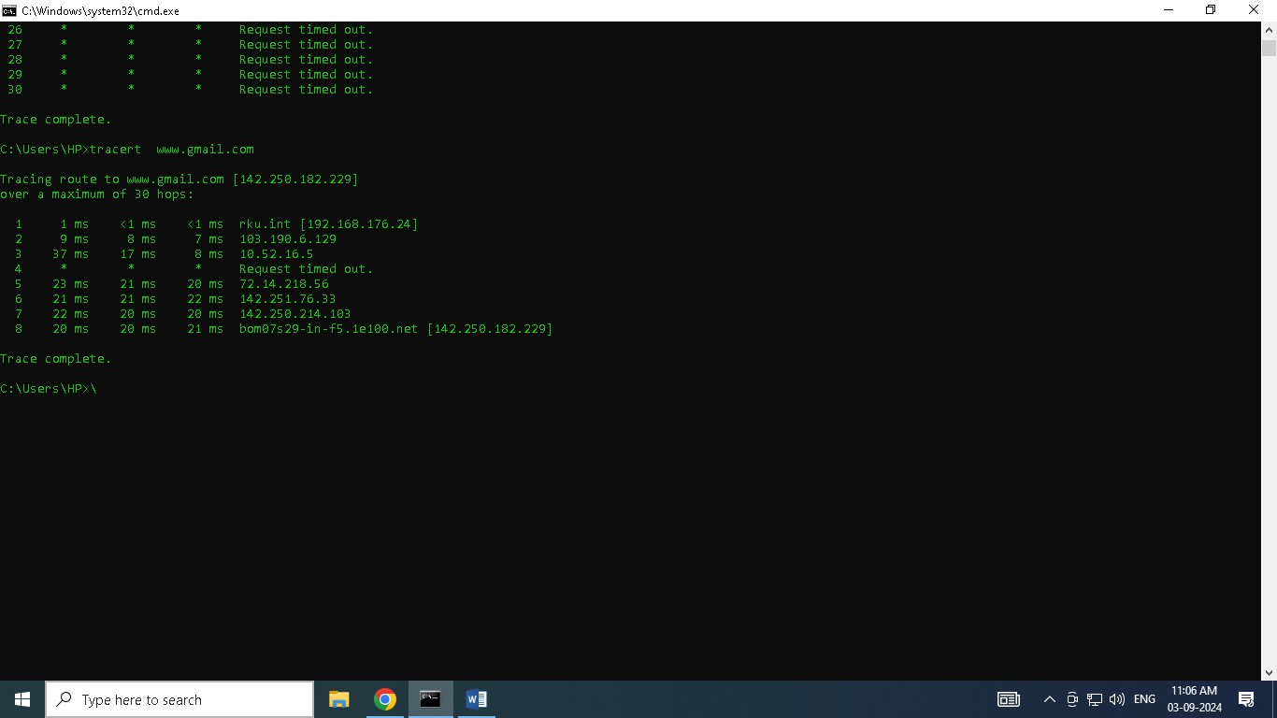

Q-3) [http://www.bhaskar.com](http://www.bhaskar.com/)

ANS- tracert [www.bhaskar.com](http://www.bhaskar.com/)

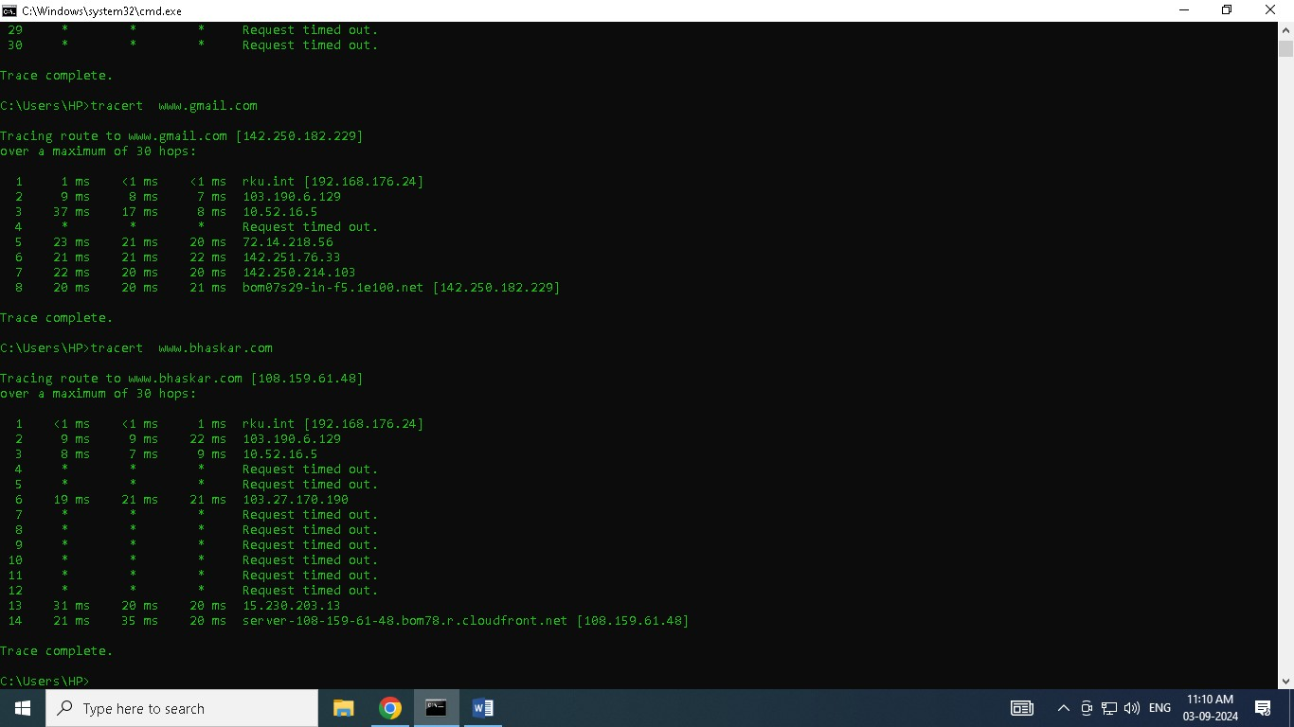

--------------------------------------------About tracert-------------------------------------------------

tracert (short for "trace route") is a network diagnostic command used in Windows to trace the path that data packets take from your computer to a destination website or server. It lists each hop (router or server) along the way, showing the time it takes for the packet to travel to each point.

* Purpose: Diagnose network issues, such as identifying where delays or failures occur in the path.
* Usage: tracert [hostname or IP address]
* Output: Lists each hop, its IP address, and the time (in milliseconds) it takes for the packet to reach that hop.

It’s useful for troubleshooting slow connections or identifying network bottlenecks.